Plean do Rang 3 agus Rang 4 20/05/2020 -26/05/2020
Dialann ‘Well-Being’ lch 20
- Good to be Me Accepting ourselves just as we are is really important for our wellbeing.
Gníomhaíochtaí Cruthaitheacha agus taitneamhacha/Creative and Fun activities to do.
- Oideas nua/New Recipe: Seo oideas gur féidir leat a thriail. Déan cinnte go bhfuil na comhábhair cearta agat roimhré agus bíodh duine fásta sa chistin leat. Pick one of the cooking workshops and follow the recipe. Make sure, in advance, that you have all the ingredients and that a grown helps you.
https://www.rte.ie/player/series/ár-mbia-ár-slí/SI0000006050?epguid=IP000065251
- Císte Seacláide/ Choc cake (30) nó Toirtín Úll/ Apple tart (45)

- Aclaíocht/ Exercise and skills Gluais go Maith, Gluais go Minic
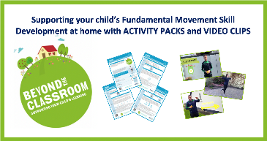
Gníomhaiochtaí sa Bhaile(A): Ag Rith (Réamhaclaíocht; Cleachtadh; Dúshlán sa bhaile) https://vimeo.com/404411732
Gníomhaiochtaí sa Bhaile(B): Ag Rith https://vimeo.com/404410116
Gníomhaiochtaí sa Bhaile(C): Ag Rith https://vimeo.com/404412677

Teicnící Chun Do Scíth a Ligean/Ways to Relax.
Éist le ceol na n-éan 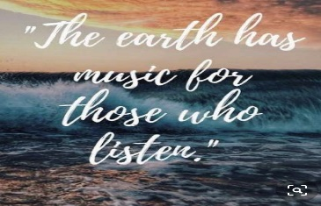
https://www.facebook.com/211490781616/posts/10158625463166617/?d=n
Aireachas le Ciarán
https://www.youtube.com/watch?v=n45vPBaHjio

