Plean do Rang 1 agus Rang 2 03/06/2020 -09/06/2020

Gníomhaíochtaí Cruthaitheacha agus taitneamhacha/Creative and Fun activities to do.
Oideas nua/New Recipe:
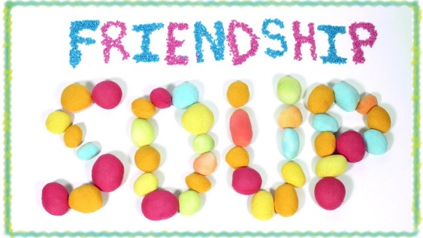
Féach ar an bhfíseán https://youtu.be/H7w7yXkJTu0

Scríobh Oideas don Chairdeas:
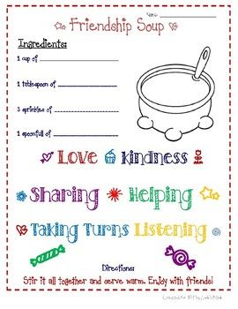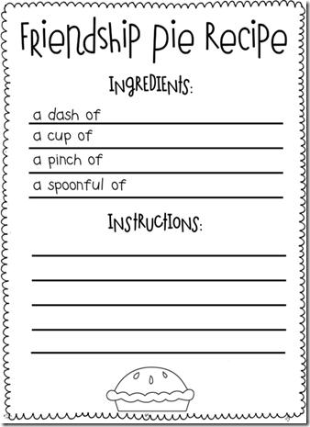
http://ayearofmanyfirsts.blogspot.com/2013/01/the-book-nook-enemy-pie.html?m=1
- A Short Story on Kindness: https://youtu.be/8Wi0UWLeT9I
- Scannáin bunaithe ar Chairdeas:
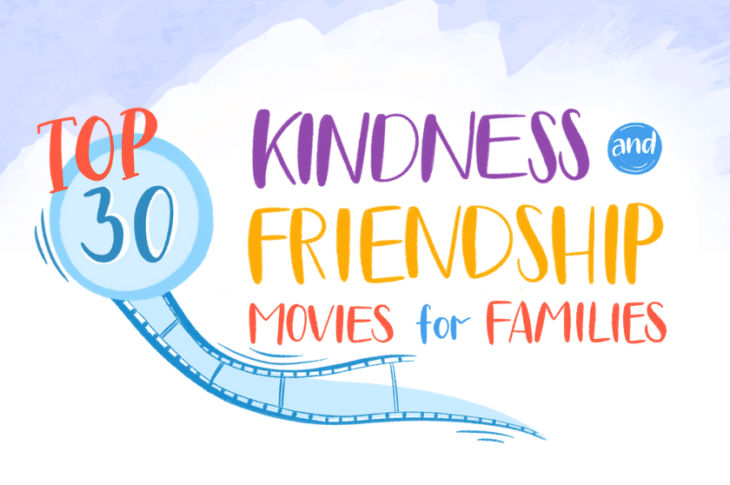
https://biglifejournal.com/blogs/blog/top-kindness-friendship-movies
