Plean do Rang 5 agus Rang 6 03/06/2020 -09/06/2020

Gníomhaíochtaí Cruthaitheacha agus taitneamhacha/Creative and Fun activities to do.
Oideas nua/New Recipe: Scriobh oideas le haghaidh Chairdis
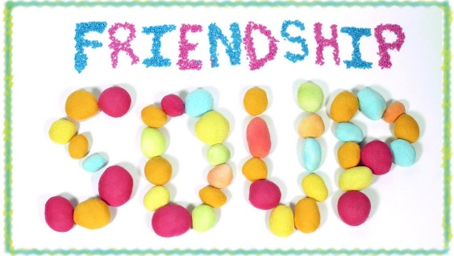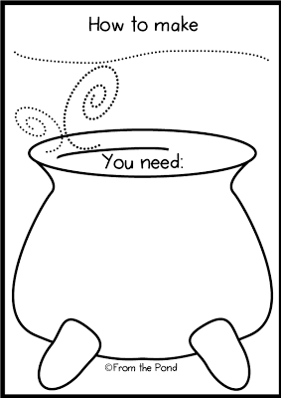
Féach ar an bhfíseán https://youtu.be/H7w7yXkJTu0

Why be Kind? Físean https://youtu.be/UCCb85TgeEU
Acts of Kindness : https://youtu.be/GdYJr03eJjE

- Kindness Wordsearch
https://worksheetplace.com/index.php?function=DisplaySheet&sheet=Kindness-Worksheet-9&links=2&id=4371&link1=31&link2=480

- Scannáin:
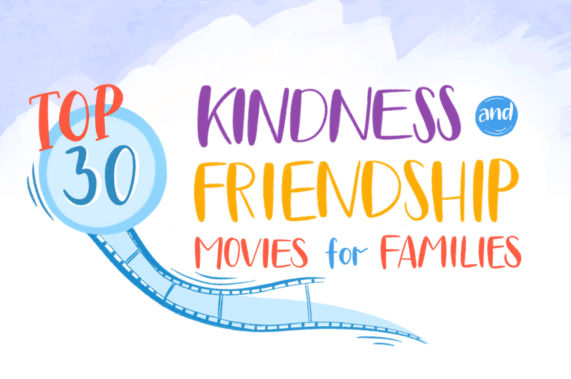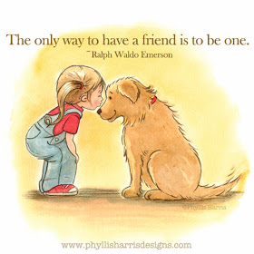
https://biglifejournal.com/blogs/blog/top-kindness-friendship-movies

