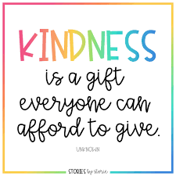 Plean do Rang 3 agus Rang 4
03/06/2020 -09/06/2020

Gníomhaíochtaí Cruthaitheacha agus taitneamhacha/Creative and Fun activities to do.
- Oideas nua/New Recipe: Scríobh Oideas le haghaidh Chairdis
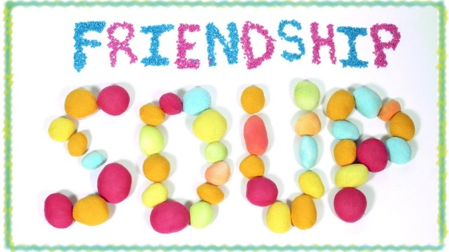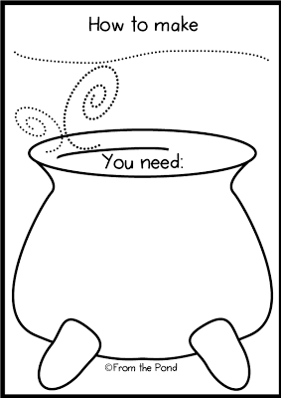
Féach ar an bhfíseán: https://youtu.be/H7w7yXkJTu0

Acts of Kindness: https://youtu.be/GdYJr03eJjE
- Kindness Wordsearch
https://worksheetplace.com/index.php?function=DisplaySheet&sheet=Kindness-Worksheet-9&links=2&id=4371&link1=31&link2=480

- Scannáin:
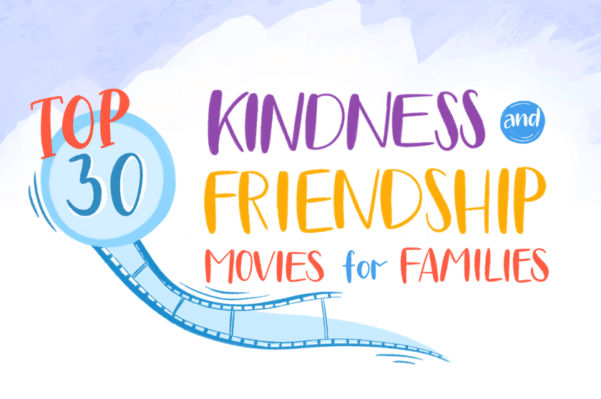
https://biglifejournal.com/blogs/blog/top-kindness-friendship-movies

