Plean do na Ranganna Naíonáin 17/06/2020 -24/06/2020

Dialann ‘Well-Being’
https://www.otb.ie/wp-content/uploads/2020/04/At-Home-with-Weaving-Well-being-A-Mental-Health-Journal-for-Kids.pdf

Being Brave lch 17
Pléigh an leathanach seo le duine fásta/ Discuss this page with a grown up and then watch the short videos.

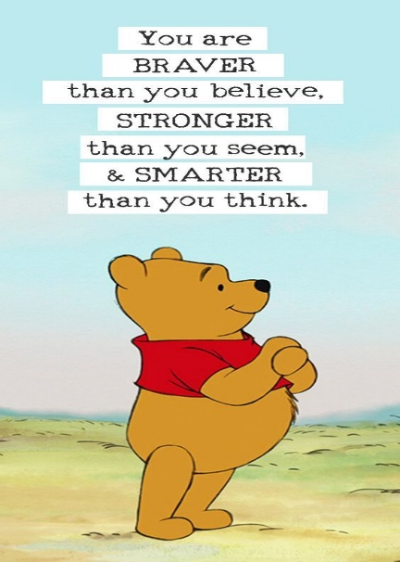

Be Brave Little Penguin https://youtu.be/jyvY80VNnCw
What is Courage? https://youtu.be/rkg-ffNGv_E

Teicnící Chun Do Scíth a Ligean/Ways to Relax.

Seaside Relaxation: Visualisation for children guided by Nuala
https://soundcloud.com/user-547419318/seaside-relaxation-visualisation-for-children-guided-by-nuala

