Plean do Rang 5 agus Rang 6 17/06/2020 -24/06/2020
Dialann ‘Well-Being’
https://www.otb.ie/wp-content/uploads/2020/04/At-Home-with-Weaving-Well-being-A-Mental-Health-Journal-for-Kids.pdf

- Being Brave lch 17 & 18
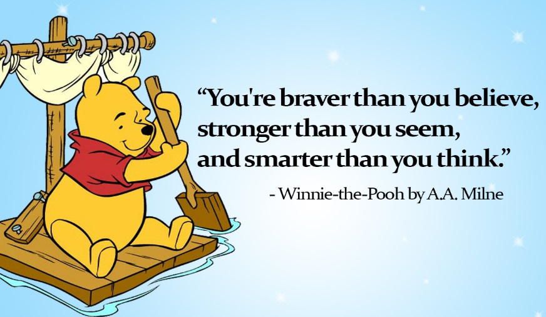

Teicnící Chun Do Scíth a Ligean/Ways to Relax.

Ag Éisteacht leis an nGaoth- PDST Primary Health and Well-Being
https://soundcloud.com/user-547419318/ag-eisteacht-leis-an-ngaoth-emma

Mindfulness with Paula
https://drive.google.com/file/d/1tBtfxRqK5IV516HuQtHOPsqkjquGcRCh/view?usp=sharing

