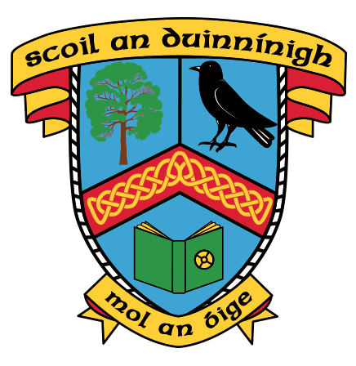

Foirm Iarratais don scoilbhliain 2023/2024 amháin

Application Form for 2023/2024 school year only

Léigh ár bPolasaí Iontrála go cúramach sula líonann tú an fhoirm seo, le do thoil.

Please read our Enrolment Policy carefully before filling in this form.

Glacfaidh an scoil le hiarratais do Naíonáin Shóisearacha 2023/24 idir an 1 Samhain 2022 agus an 9 Eanáir 2023.

The school will accept applications for Junior Infants for the school year 2023/24 from 1st November 2022 to 9th January 2023.

Ainm an Pháiste Child’s name and surname

Inscne Gender

Uimhir Phearsanta Seirbhíse Poiblí P.P.S.Number

Seoladh an Pháiste Home Address

Eircode

Dáta Breithe Date of Birth
_______ /______/__________

Ainm an Athar Father’s name | Guthán Father’s Telephone No. | Ríomhphost Father’s Email
Ainm na Máthar Mother’s name | Guthán Mother’s Telephone No. | Ríomhphost Mother’s Email

An bhfuil do pháiste á thógáil trí mheán na Gaeilge? Tá/Yes ______ Níl/No ______
Is your child being raised through the medium of the Irish Language?
Tabhair sonraí faoi aon deartháir nó deirfiúr sa chlann atá ag freastal nó a d’fhreastal ar an scoil seo.
Please provide details of any brothers and sisters attending or who attended this school.

An bhfuil tuismitheoir leis an bpáiste ag obair i Scoil an Duinnínigh? Tá/Yes _______ Níl/No ______
Is either parent of the child working in Scoil an Duinnínigh?
An bhfuil an páiste ag freastal ar naíonra? Tá/Yes _______ Níl/No ______
Is the child presently attending an Irish-language Pre-school?

Más ‘sea, breac síos Ainm agus Seoladh an Naíonra
If Yes, please indicate Name and Address of Naíonra

Líofacht Ghaeilge | Level of Fluency in the Irish Language

An bhfuil leibhéal líofachta sa Ghaeilge ag do pháiste? (Fáilte roimh fhianaise chuige seo; féach polasaí rollú.)

Has your child attained a level of fluency in the Irish language indicative of what would be expected of a student who uses the Irish language as a normal means of communication in a non-educational environment, taking into account the age and any special educational needs of the student concerned and that the said fluency would be likely to regress were the student not admitted to an Irish language school.
(Evidence is welcomed. Please refer to the admission policy.)

Tá/Yes _______ Níl/No_____

Aon eolas breise atá fóinteach don iarratas Additional information that you consider relevant to the application

Ní hionann foirm iarratais comhlánaithe agus dearbhú go mbeidh áit ar fáil i Scoil an Duinnínigh
The completion of an application form does not guarantee a place at Scoil an Duinnínigh

Siniú Tuismitheora: …………………………………………………….. (máthair / athair). Dáta: ………………
Parent’s signature Date

